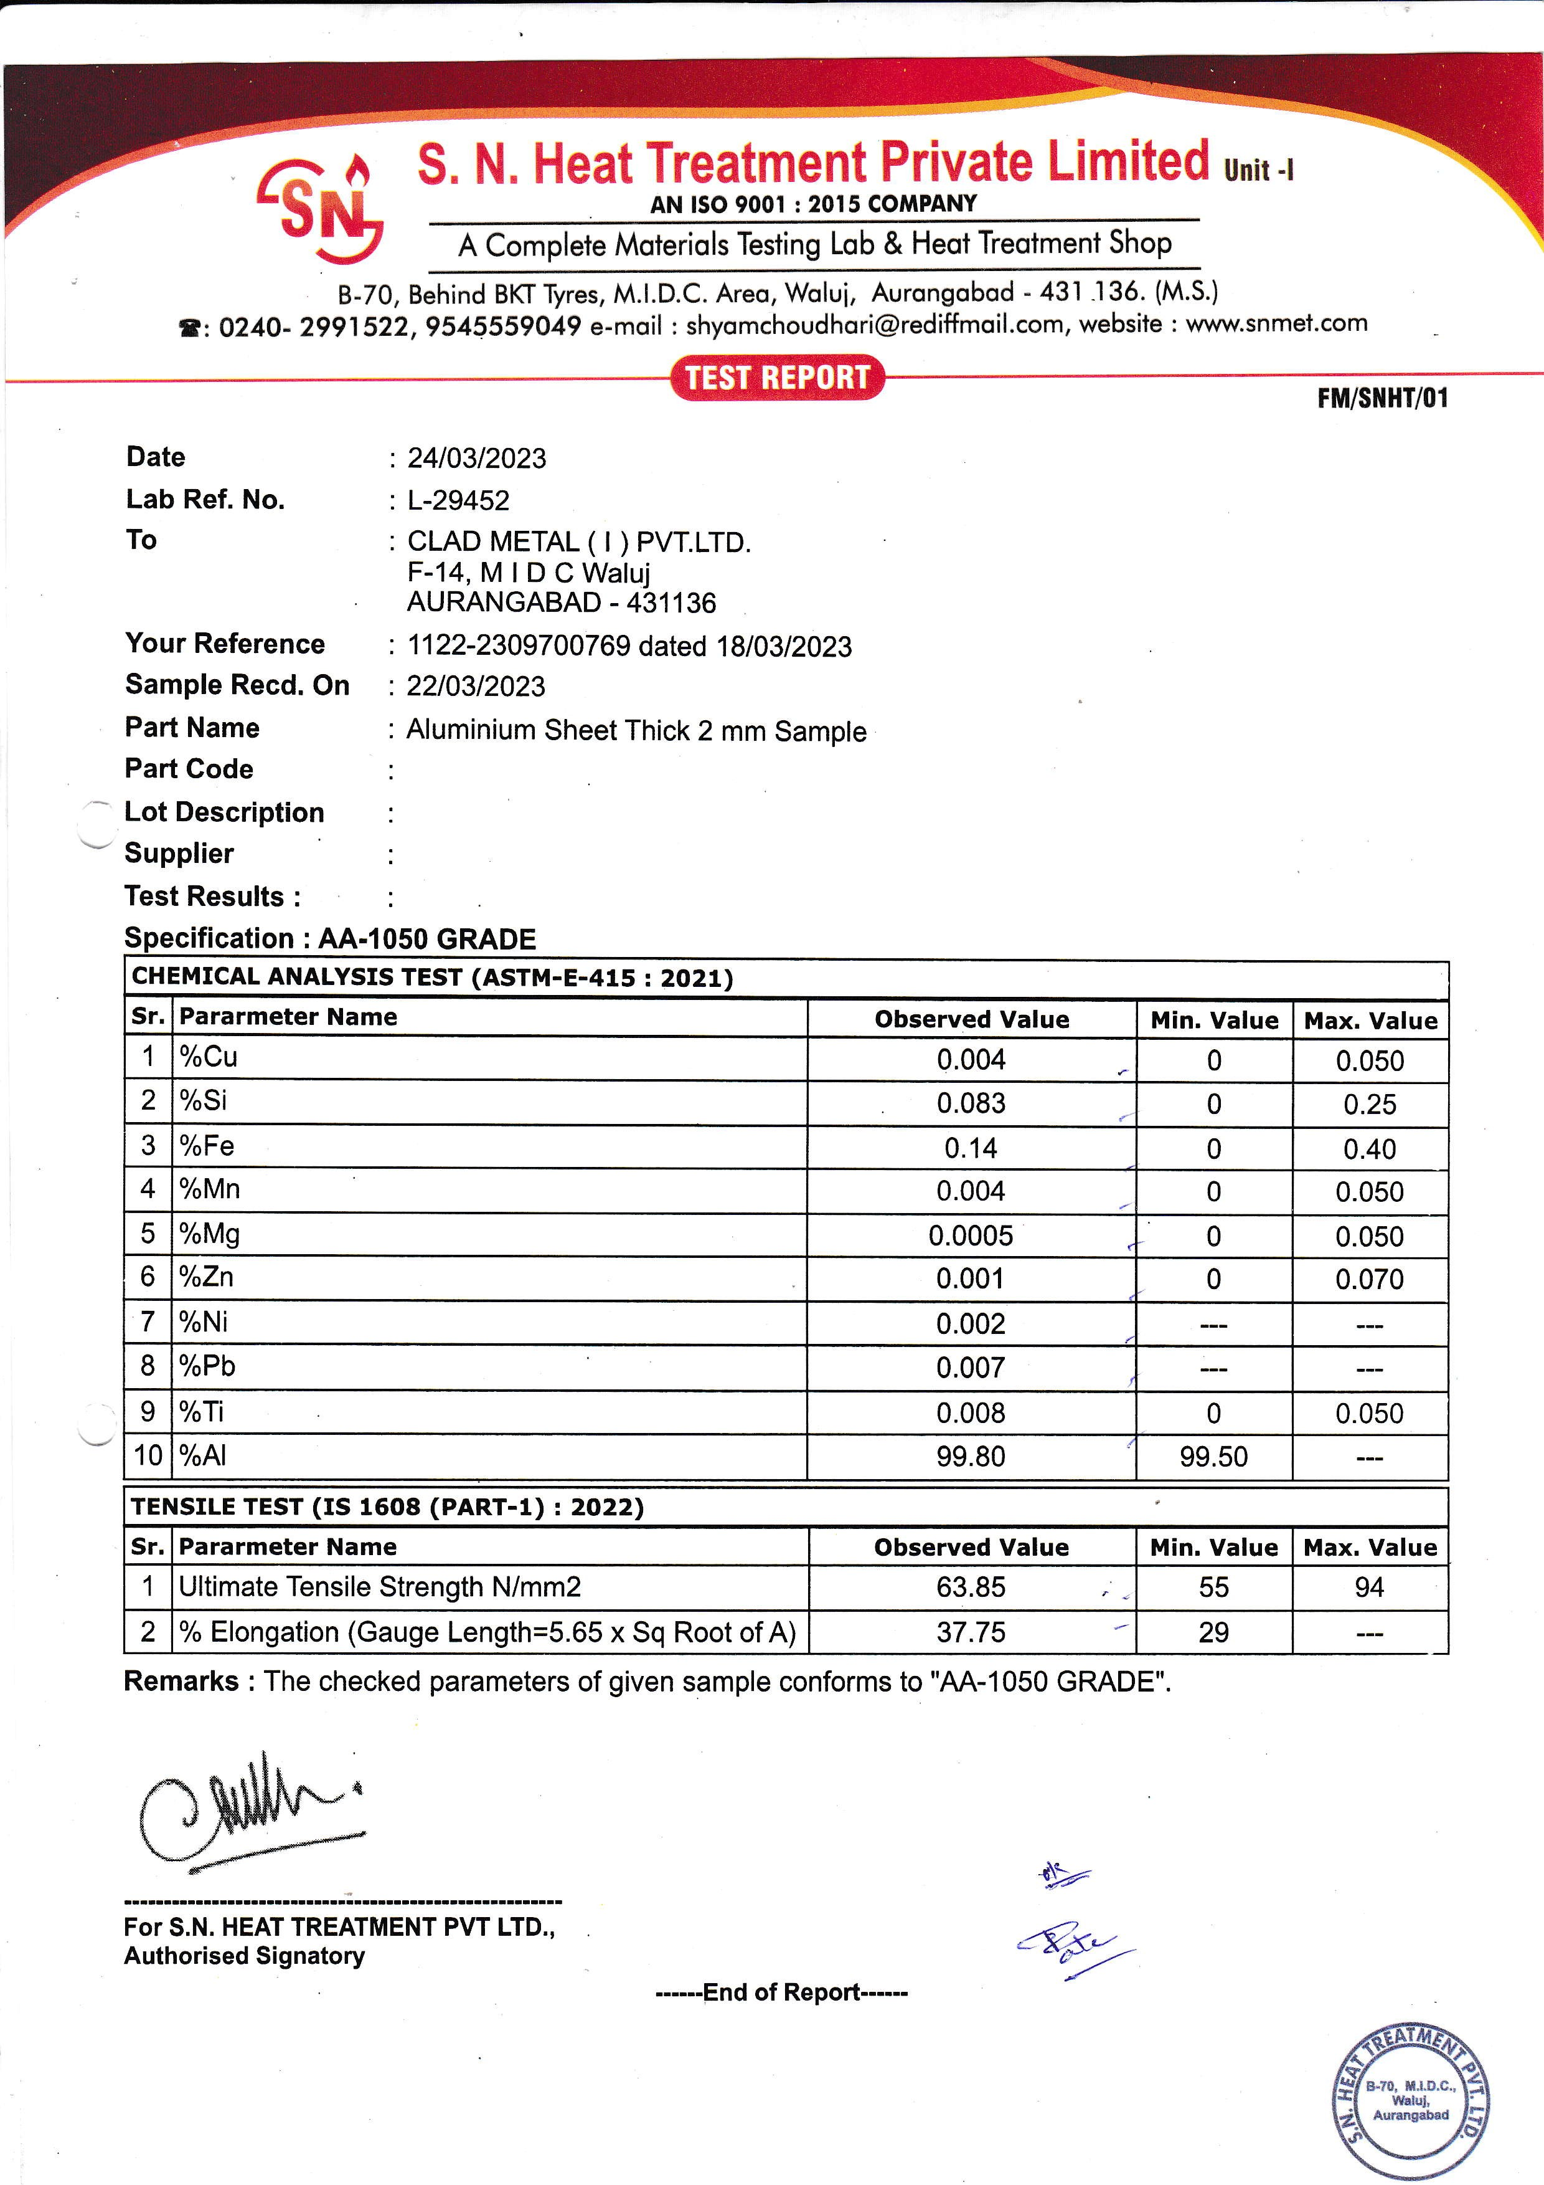

|  |  |  |  |  |  |
| --- | --- | --- | --- | --- | --- |
| **Date :** 18/06/2023 | | | | | |
| **Lab Ref.No :** L-10421 | | | | | |
| **To :** CLAD METAL ( I ) PVT .LTD | | | | | |
| F-14 M I D C Waluj | | | | | |
| AURANGABAD - 431136 | | | | | |
| **Your Reference :** 0787 dated 16/06/2023 | | | | | |
| **Sample Recd.On :** 17/06/2023 | | | | | |
| **Part Name :** Al Tube Size 8 X 0.7 mm Sample | | | | | |
| **Part Code :** | | | | | |
| **Lot Description :** | | | | | |
| **Supplier :** | | | | | |
| **Test Results :** | | | | | |
| **Specification : ALUMINIUM -1070-O GRADE** | |  |  |  | |
| **CHEMICAL ANALYSIS TEST (ASTM-E-1086)** | | | | | |
| **Sr.** | **Parameter Name** | **Observed Value** | **Min.Value** | **Max.Value** | |
| 1 | % Cu | 0.002 | 0 | 0.030 | |
| 2 | %Si | 0.047 | 0 | 0.20 | |
| 3 | %Fe | 0.12 | 0 | 0.25 | |
| 4 | %Mn | 0.001 | 0 | 0.030 | |
| 5 | %Mg | 0.001 | 0 | 0.030 | |
| 6 | %Zn | 0.007 | 0 | 0.030 | |
| 7 | %Al | 99.82 | 99.70 | -- | |
|  |  |  |  |  | |
| **TENSILE TEST (IS 1608)** | | | | | |
| **Sr.** | **Parameter Name** | **Observed Value** | **Min.Value** | | **Max.Value** |
| 1 | Ultimate Tensile Strength N/mm2 | 67.24 | 0 | | 93.14 |
| 2 | %Elongation (Gauge Length = 5.65 X Sq of CS Area) | 47.10 | 25 | | -- |
| **Remarks:** The Checked parameters of given sample conforms to ''ALUMINIUM 1070-O GRADE ''. | | | |  | |